Design of Reconfigurable MIMO Antenna with Enhanced Performance for 5G Applications
Adrishikhar Chowdhury, Sounak Mal, Subhrajit Nandy, Poulami Mukherjee
and Dr. Juin Acharjee

St. Thomas College of Engineering & Technology, Kolkata
adrishikharc@gmail.com
Abstract. This paper presents the design and performance analysis of a compact, reconfigurable 8x8 superwideband (SWB) multiple-input–multiple-output (MIMO) antenna designed for high-capacity wireless communication applications. It is an improvement of a work which was already presented. The antenna utilizes microstrip line-fed half-circular radiating elements arranged with rotational symmetry on an FR-4 substrate. To enhance impedance bandwidth and inter-element isolation, a modified connected partial ground plane with a rectangular slot is integrated into the design. To introduce switchable frequency characteristics, a T-shaped stub is connected to the partial ground plane via a cadmium sulphide (CdS)-based photoconductive semiconductor switch. Under optical stimulation from a light-emitting diode (LED), the antenna's operating characteristics undergo a distinct transformation: in the switch-off (unilluminated) state, the antenna achieves a reconfigurable band of 8–16 GHz, whereas in the switch-on (illuminated) state, it delivers a superwideband performance spanning 2–20 GHz (10:1 ratio), effectively covering multiple bands including the sub-6 GHz region. Due to the symmetrical arrangement and orthogonal orientation of the elements, the antenna achieves stable radiation patterns, high port isolation, and excellent pattern diversity. The diversity performance is rigorously evaluated using key MIMO parameters, demonstrating an envelope correlation coefficient (ECC) below 0.001, high diversity gain (DG), and minimal channel capacity loss (CCL) for both ON and OFF conditions of the photoconductive semiconductor switch. The combination of a compact footprint, optically reconfigurable band states, wide impedance bandwidth, and outstanding MIMO diversity makes this antenna highly suitable for modern broadband and multi-standard wireless communication systems
Keywords: SWB, MIMO, Pattern Diversity, Microstrip Antenna, Reconfigurable, Photoconductive.
1 Introduction
An increasing number of wireless communication devices require compact antenna systems with a higher data transfer rate. MIMO (Multiple Input Multiple Output) , a high channel capacity and multi deploying high gain antenna system, plays a vital role in 5G standards, since the large number of elements installation leads to inevitable mutual coupling. Reconfigurable MIMO antennas are made by using switches from PIN diodes, varactor diodes or photoconductive switches to operate in multiple frequency bands with different values of gain and isolation. These compact and compatible with integrated circuits antenna systems have the advantage of supporting multipurpose capabilities with high gain and bandwidth.

Several designs have been proposed to construct reconfigurable MIMO antenna systems for operating in the 5G band over the years. A report mentions the work on a Quad Port Multipolarized Reconfigurable MIMO Antenna, consists of four offset-fed monopole antenna elements of 60×65 mm². By controlling the PIN diode’s bias states, the polarization diversity is being achieved. It exhibits isolation greater than 15 dB and ECC less than 0.13 [1]. Another paper reports about a reconfigurable MTM-EMBG MIMO antenna array integrated with solar panel, helping antenna performance degradation and mutual coupling limitations. It comprises of metamaterial radiating patch made of 5x3 Hilbert-Curve Split Ring Resonator Array (SRR), enhancing IBW and gain. The mutual coupling reduces due to composite right/left handed isolation wall between antenna elements. PIN diodes helped in the frequency reconfigurability and enabled dynamic control of the operating bands and radiation characteristics, operating over a frequency range of 2.7-6 GHz and achieves a maximum gain of ≈7.3 dBi [2]. Another report comprises of an ultrawideband to dual-band switchable antenna design consists of a switchable planar monopole antenna operating in UWB and dual-band mode. The switching is triggered by a photoconductive semiconductor switch triggered by a LED. In switch off state, operating in ultrawide/dual band and for switch on state, converts to a dual band antenna [3]. Another report comprises of the design and evaluation of reconfigurable antenna array consists of two printed dipoles separated by a distance of quarter wavelength and the dipoles are reconfigurable by PIN diodes. The configuration effects mutual coupling and it leads to different degrees of pattern diversity. This leads to improving link capacity in average of 10% and 8% and SNR of 10 and 20 dB [4]. Another work has been done on compact reconfigurable MIMO antenna comprising of four element MIMO antenna of 26 x 26 x 0.8 mm³. It operates in 5.2 GHz or 3.5 GHz, demonstrating good impedance matching at both operating frequencies and isolation levels at 25 dB and 21 dB, ECC < 0.0001, DG around 10 dB for both frequencies, peak realized gains of 3.5 dBi (at 3.5 GHz) and 4.8 dBi (at 5.2 GHz) [5]. Furthermore, a report shows a pattern reconfigurable antenna design of a two port MIMO antenna system based on the selective excitation of three orthogonal characteristic modes. The selective excitation mode is achieved by integrating two pairs of capacitive coupling elements (CCEs), achieves good impedance matching, providing the feedings to CCEs. The PIN diodes in each feed network varies the selective excitation modes and results reconfigurable patterns and ECC >>0.5 [6]. An additional study highlights the idea of using reconfigurable intelligence surface (RIS), which compensates performance loss due to antenna selection. RIS assisted massive MIMO, a new architecture, enhances system performance while having low hardware cost. This is achieved by maximizing channel capacity, passive beamforming while checking the cardinality constraints of active antennas [7].

In this paper, a reconfigurable compact eight-port superwideband MIMO antenna is proposed for broadband wireless communication applications. The design has already been proposed and employs microstrip line-fed half-circular radiating elements with rotational symmetry and a modified partial ground plane, achieving wide impedance bandwidth, high isolation, and effective pattern diversity over 2–20 GHz[presented]. In extend of the presented paper, here the same MIMO antenna has been modified into adding a cadmium sulphide (CdS) photoconductive switch in the unit cell of the antenna. By changing the state of the switch into on and off, the condtions of the MIMO antenna is evaluated by standard diversity metrics, confirms the proposed antenna is suitable for high-capacitive wireless systems. Ansys High-Frequency Structure Simulator (HFSS) is used to verify the performance of the proposed antenna in software environment.
2 Antenna Design
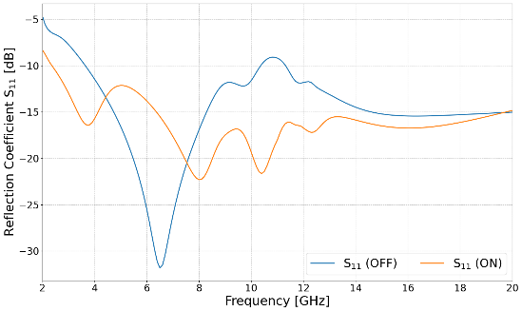
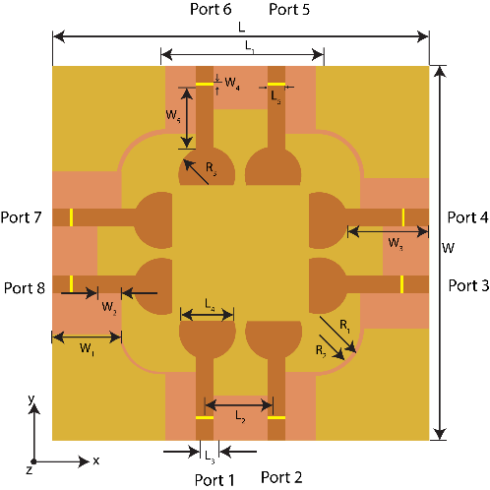
The proposed antenna’s structure has been shown in the Fig. 1. As the antenna structure has already been discussed [presented]. A photoconductive semiconductor switch made of cadmium sulphide (CdS) has been placed by cutting a portion from the antenna element. The behavior of the photoconductive semiconductor in switched on (illuminated) state or off (non-illuminated state) has been observed and documented in this report.
Fig 1. Geometry & design parameters of the proposed eight port SWB- MIMO antenna: [L1=24mm, L2=10mm, L3=2.7mm, L4=10 mm, L5=2.7mm, W1= 10 mm, W2=5 mm, W3=12.5mm, W4=0.4mm, W5=9.25mm, R1=7.2mm, R2=6.5mm, R3=4.2mm]

Fig 2. S₁₁ Performance of the reconfigurable 8 port MIMO antenna.
Fig. 2 illustrates the design’s S₁₁ performance of the antenna element in switched on (illuminated) state and switched off (non-illuminated) state. The proposed 8x8 reconfigurable MIMO antenna exhibits different results in switch on/off state. Switched ON state shows the impedance matching and a wide -10 dB impedance bandwidth spanning from 2-20 GHz. At switched OFF state, it shifts its S₁₁ response to provide reconfigurable performance with a distinct deep resonance around 6.5 GHz.
3 Results And Discussion
3.1 S-Parameter Performance
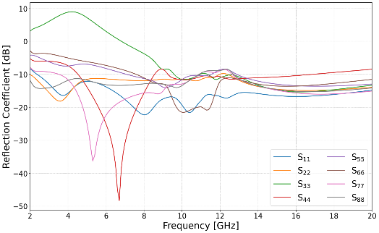
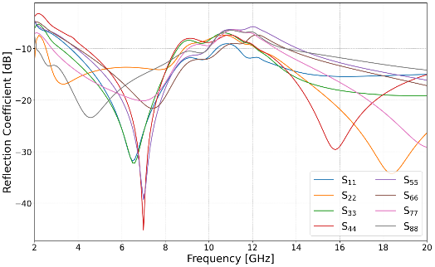
Fig. 3 exhibits Reflection Coefficients (S₁₁-S₈₈) performance of the reconfigurable eight-port SWB-MIMO antenna design. Fig. 4(a) shows switched ON state, the ports achieve a wide -10 dB impedance bandwidth and covers major UWB spectrum (> 180% fractional bandwidth) with notable resonance dips around 5.3 GHz and 6.7 GHz. Fig. 4(b) shows switched OFF state and shows dynamic frequency reconfigurable characteristics and maintain S₁₁ < 10 dB.
(a) (b)
Fig 3. Reflection Coefficients in switched (a) ON and (b) OFF state (simulated) of the proposed eight-port SWB-MIMO antenna.

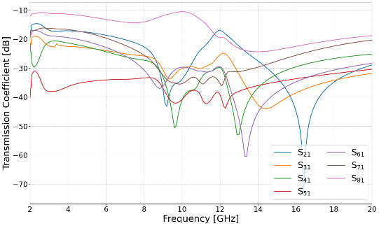
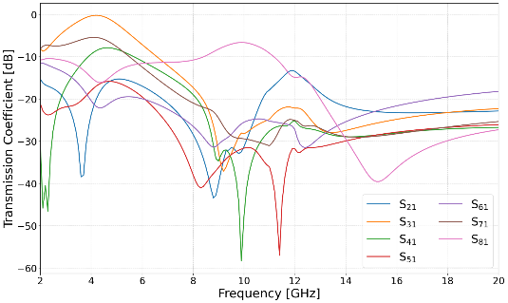
Fig 4 exhibits the transmission coefficients (S₂₁–S₈₁) performance of the antenna. The isolation performance between the antenna elements confirms minimal coupling in both switched on/off states. Fig 5(a) shows ON state and transmission coefficients remains under -15 dB across most bands and dips significantly below -30 dB to -50 dB near 8-14 GHz. Fig 5(b) shows OFF state, element isolation is further improved, stays well below -15 dB across the entire range of 2-20 GHz and reaches extremely low coupling levels (below -40 dB) at various high frequency points.
(a) (b)
Fig 4. Transmission Coefficients in switched (a) ON and (b) OFF state (simulated) of the proposed eight-port SWB-MIMO antenna.

ECC, DG and CCL parameters are calculated for evaluating the performance of the reconfigurable SWB MIMO Antenna System. The degree of independence between antenna elements evaluated by means of ECC, and derived from the antenna’s S-parameters as expressed below:
$$ECC=\frac{\left|S_{i}^{*}S_{j}+S_{ⅈj}^{*}S_{jj}\right|}{\left(1-{\left|S_{i}\right|}^{2}\right)\left(1-{\left|S_{j}\right|}^{2}\right)} (1)$$
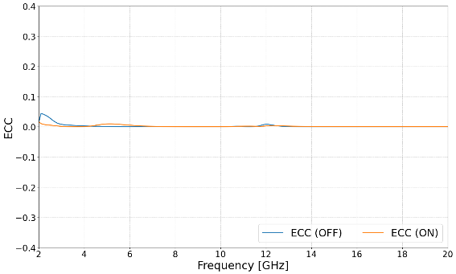
Equation (1) shows calculation of the ECC value of an antenna. Where ECC_{ij} is the ECC of the i^{th}, j^{th} antenna elements. ECC of the antenna in both switched on/off states over the operating frequency range shown in Fig. 5, and from this we can see that the value of ECC > 0.001 in both states, indicating very low correlation and excellent diversity.
Fig 5. Envelope Correlation Coefficient (ECC) in switched (a) ON and (b) OFF state (simulated) of the proposed eight-port SWB-MIMO antenna.

$DG=10\sqrt{1-ECC^{2}}$ (2)

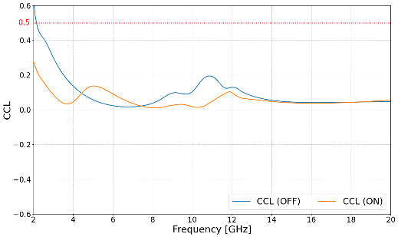
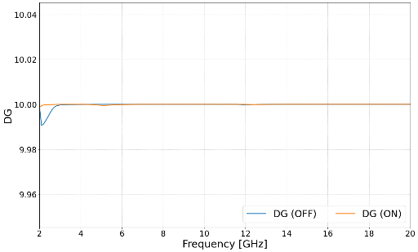
The Diversity Gain (DG) is another important factor that reflects the improvement in signal reliability. Equation (2) shows how to calculate diversity gain of an antenna. The DG variation of the reconfigurable antenna for switched on/off is depicted in Fig. 6. The DG value remains constant 10 dB across the operating band, which yields better diversity for the MIMO system.
Fig 6. Diversity Gain (DG) in switched (a) ON and (b) OFF state (simulated) of the proposed eight-port SWB-MIMO antenna.
Fig 7. Channel capacity loss (CCL) versus frequency for the proposed SWB-MIMO antenna

The loss in data transmission capacity because of correlation between antenna elements is evaluated by means of Channel Capacity Loss (CCL). Fig. 7 shows the CCL variation of the antenna in both switched on/off conditions, kept under 0.5 across the operating band in both states. For ON state, CCL stays below 0.2 across entire frequency range, dropping below 0.1 for most higher frequencies. For OFF state, the CCL remains below 0.2 above 3.5 GHz and only exceeds the threshold near below 2.2 GHz, indicating high transmission and reliable performance.
4 Conclusion
A compact reconfigurable eight-port super wideband MIMO antenna is introduced for the applications in high-capacity wireless communication systems. The design has already been presented and this is an extend of the presented work, helps to get wide IBW and high inter-element isolation. It adds an CdS switch to reconfigure the design into ON/OFF state. The results confirm an operating bandwidth from 2 to 20 GHz, and studies the different behavior of the antenna in switched ON/OFF mode. The parameters are read in both states and demonstrated through extremely low ECC (below 0.001), high diversity gain, low channel capacity loss. The compact size, wide bandwidth, and favorable diversity characteristics, makes this antenna design ideal for modern super wideband MIMO wireless communication systems.
References
- Thangarasu, Deepa, Palaniswamy, Sandeep Kumar, Thipparaju, Rama Rao, Quad Port Multipolarized Reconfigurable MIMO Antenna for Sub 6 GHz Applications, International Journal of Antennas and Propagation, 2023, 8882866, 17 pages, 2023. https://doi.org/10.1155/2023/8882866
- Al-Attar, S., Alibakhshikenari, M., Qasaymeh, Y.M. et al. A reconfigurable MTM-EMBG MIMO antenna array with solar panel integration for sustainable 5G networks. Sci Rep 16, 22140 (2026). https://doi.org/10.1038/s41598-026-48125-x
- F. M. Alnahwi, K. M. Abdulhasan, and N. E. Islam, "An ultrawideband to dual-band switchable antenna design for wireless communication applications," IEEE Antennas and Wireless Propagation Letters, vol. 14, pp. 1685–1688, 2015, doi: 10.1109/LAWP.2015.2418679.
- D. Piazza, N. J. Kirsch, A. Forenza, R. W. Heath and K. R. Dandekar, "Design and Evaluation of a Reconfigurable Antenna Array for MIMO Systems," in IEEE Transactions on Antennas and Propagation, vol. 56, no. 3, pp. 869-881, March 2008, doi: 10.1109/TAP.2008.916908.
- W. F. A. Mshwat et al., "Compact Reconfigurable MIMO Antenna for 5G and Wi-Fi Applications," in IEEE Access, vol. 12, pp. 110283-110298, 2024, doi: 10.1109/ACCESS.2024.3440653.
- K. Li and Y. Shi, "A Pattern Reconfigurable MIMO Antenna Design Using Characteristic Modes," in IEEE Access, vol. 6, pp. 43526-43534, 2018, doi: 10.1109/ACCESS.2018.2863250.
- J. He, K. Yu, Y. Shi, Y. Zhou, W. Chen and K. B. Letaief, "Reconfigurable Intelligent Surface Assisted Massive MIMO With Antenna Selection," in IEEE Transactions on Wireless Communications, vol. 21, no. 7, pp. 4769-4783, July 2022, doi: 10.1109/TWC.2021.3133272.

